**cat, less and more command**

**cat**

* Function: Prints the entire file's content to the terminal at once.
* Syntax: **cat filename**
* Best for:
  + Small files you want to quickly view in their entirety.
  + Concatenating multiple files into a single output.
  + Redirecting file content to another command for further processing.

Example:

Following is showing the content of the text file named “Spiderverse” using cat command

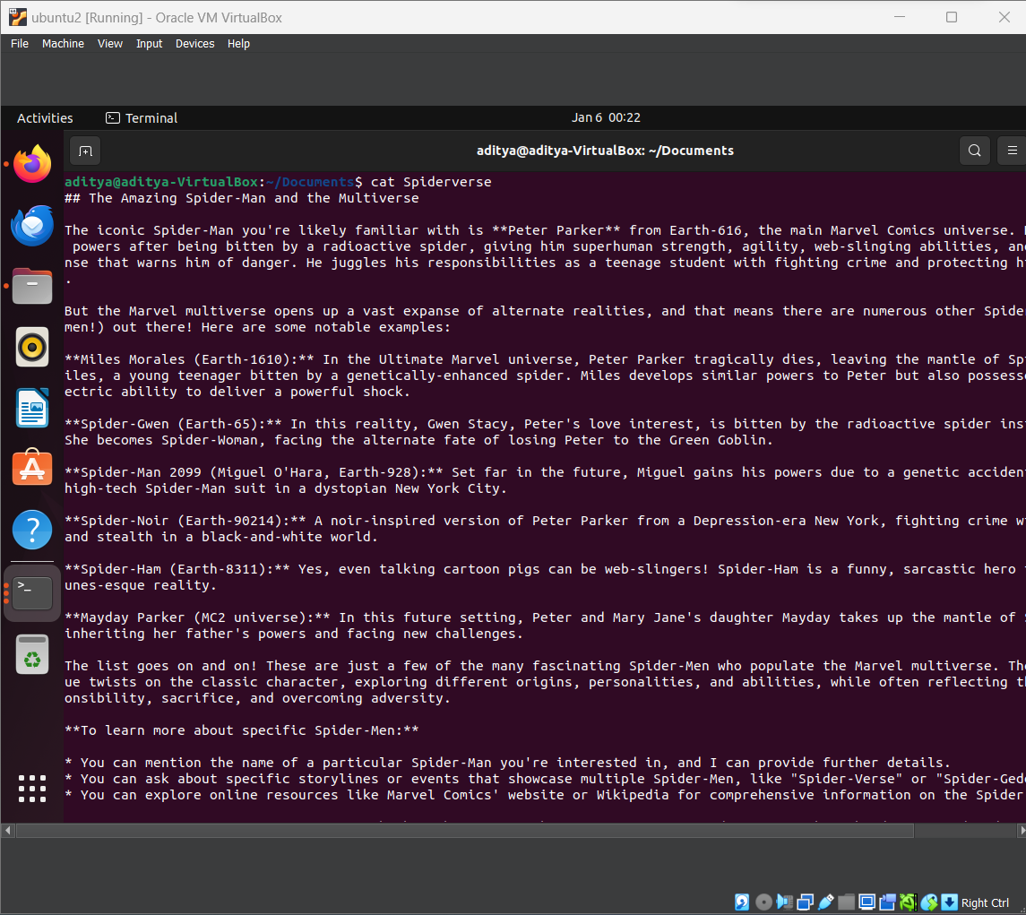

**less**

* Function: Interactive pager that displays the file one screen at a time.
* Syntax: **less filename**
* Features:
  + Scrolling up/down using arrow keys or Page Up/Down.
  + Searching for text within the file (using **/** and **?**).
  + Jumping to specific lines or percentages of the file.
* Best for:
  + Large files that don't fit on a single screen.
  + When you need to navigate, search, or jump within the file.

Example:

Following is showing the content of the text file named “Spiderverse” using less command. (The text “Spider” is searched)

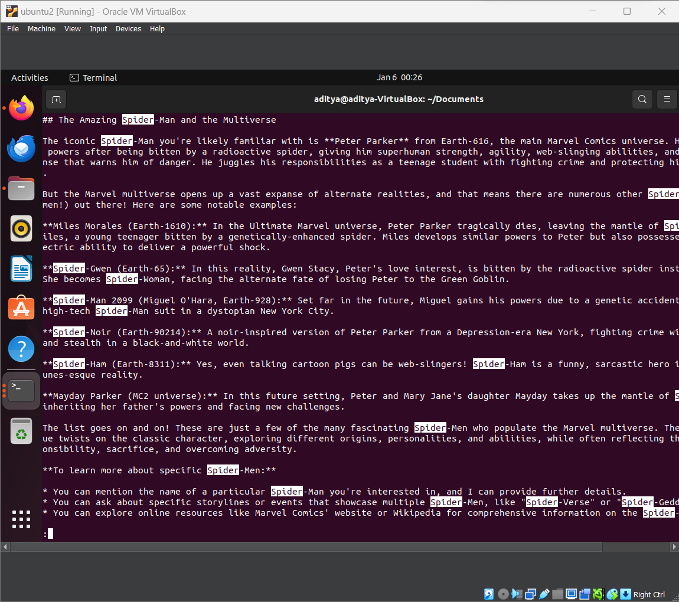

Summary of less commands:

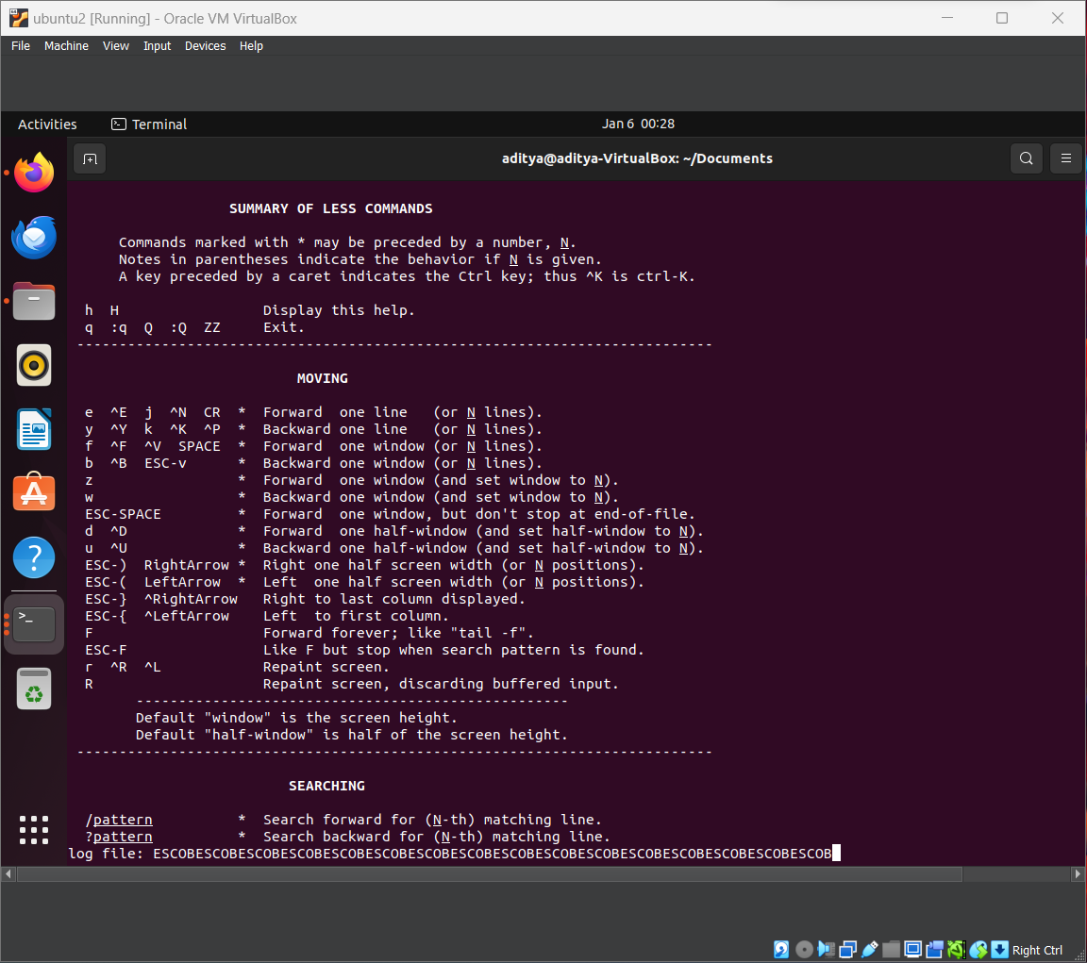

**more**

* Function: Similar to less, but with fewer features.
* Syntax: **more filename**
* Features:
  + Forward-only scrolling, no backward movement.
  + Basic searching capabilities.
* Best for:
  + Quick viewing of large files when full navigation isn't required.
  + Simpler interface for those unfamiliar with less's advanced features.

Example:

Following is showing the content of the text file named “Spiderverse” using more command.

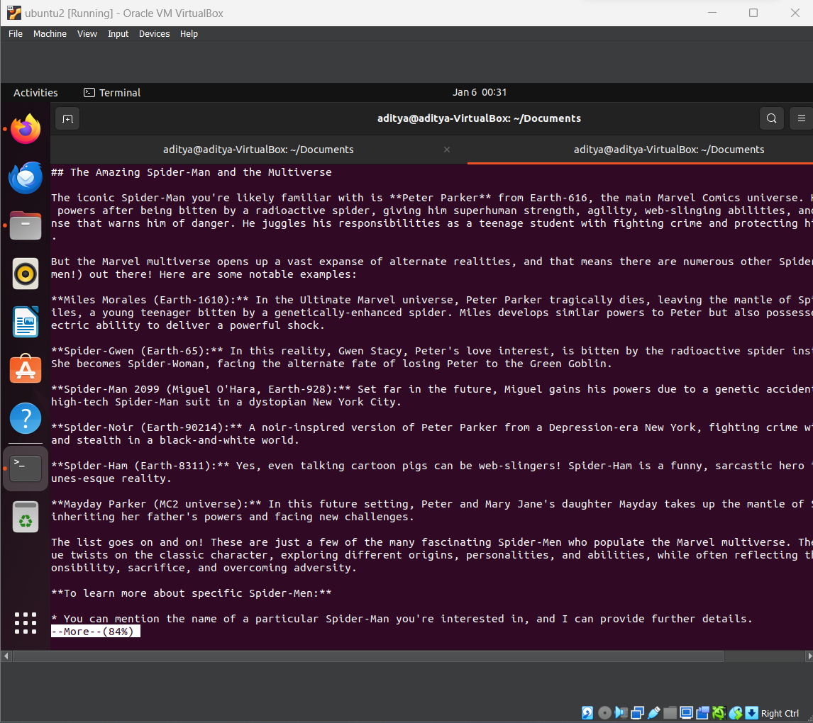

**Key Differences:**

|  |  |  |  |
| --- | --- | --- | --- |
| Feature | cat | less | more |
| Full display | Yes | No | No |
| Scrolling | No | Yes | Yes (forward only) |
| Searching | No | Yes | Yes (limited) |
| Interactive | No | Yes | Yes |
| Navigation | No | Extensive | Basic |

**In summary:**

* Use cat for quick viewing of small files or for concatenating files.
* Use less for interactive viewing, navigation, and searching within large files.
* Use more for simple, forward-only viewing of large files.